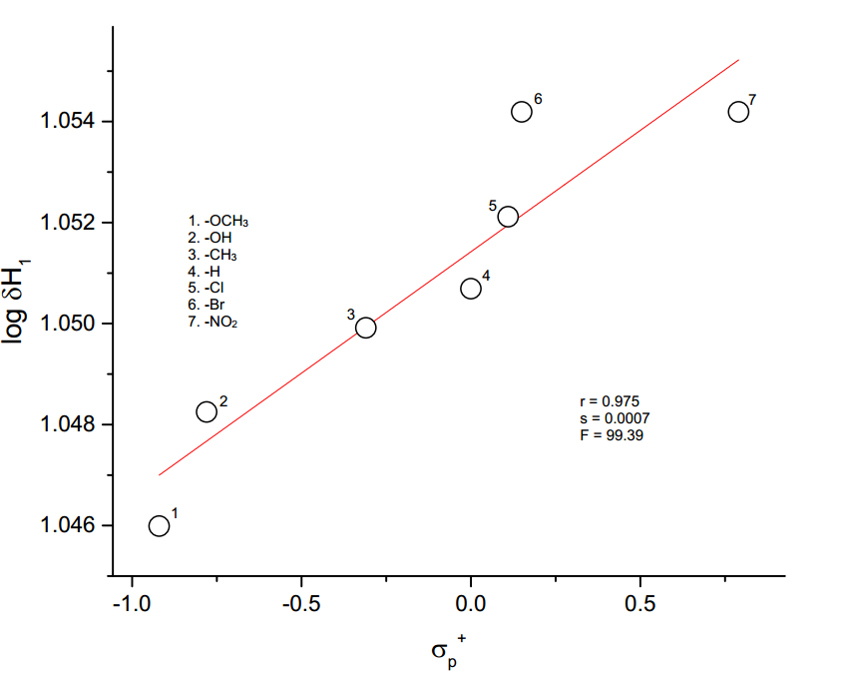

**Figure 3.2.** The plot of log δH1  vs *σp+*